Pose 1 00:00:02:23

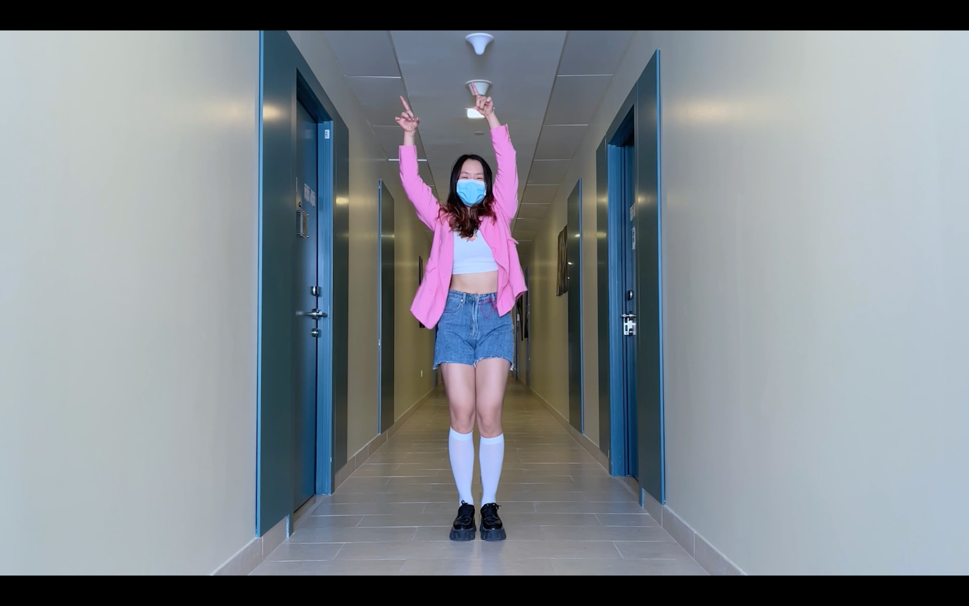

Pose 2 00:00:04:15

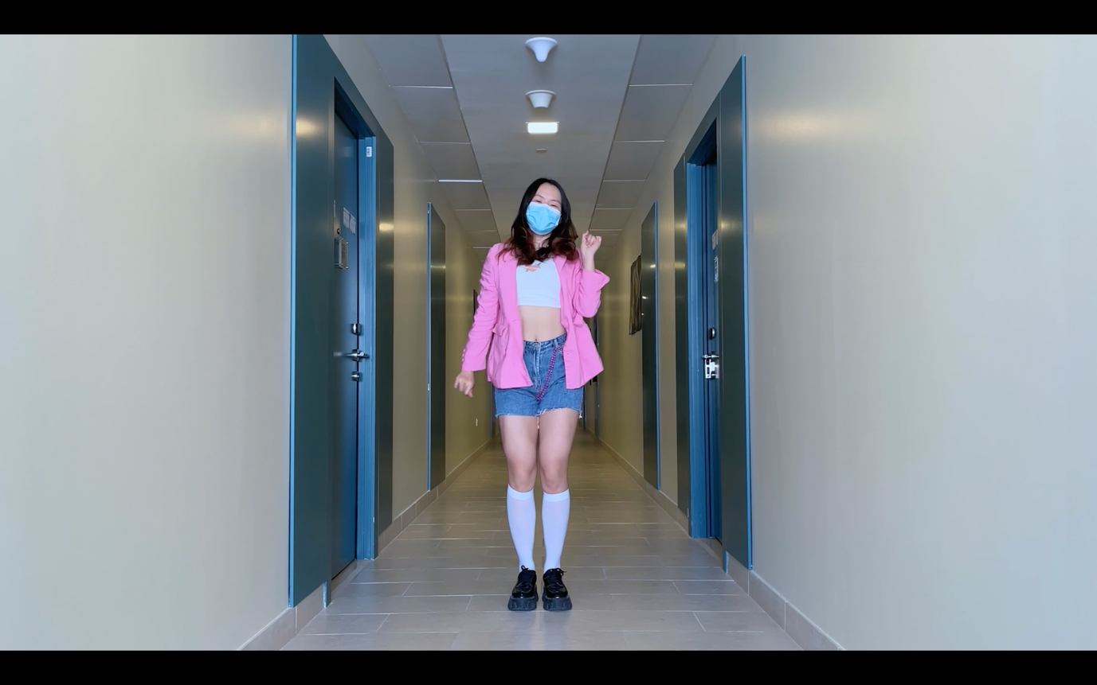

Pose 3 00:00:06:20

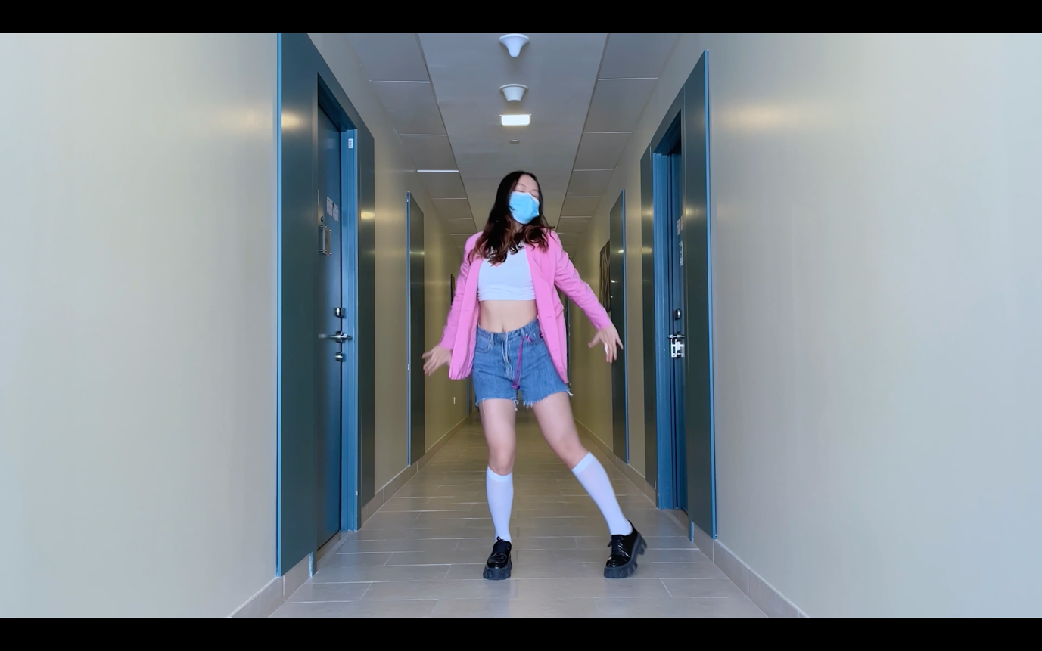

Pose 4 00:00:11:15

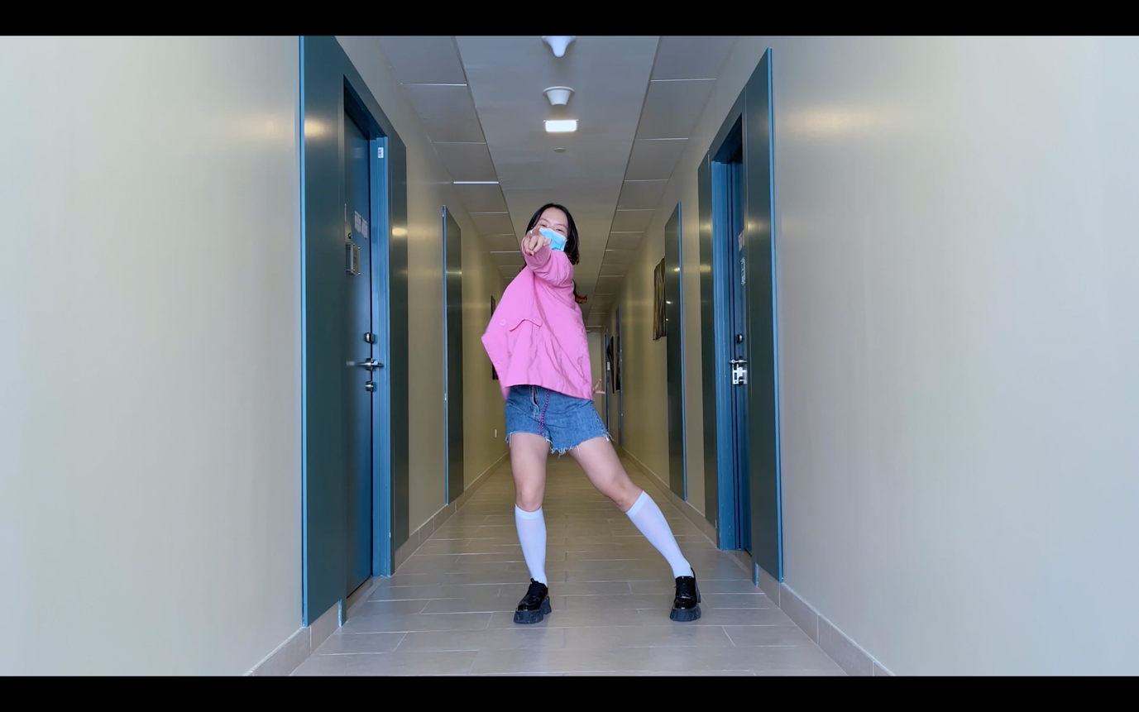

Pose 5 00:00:12:19

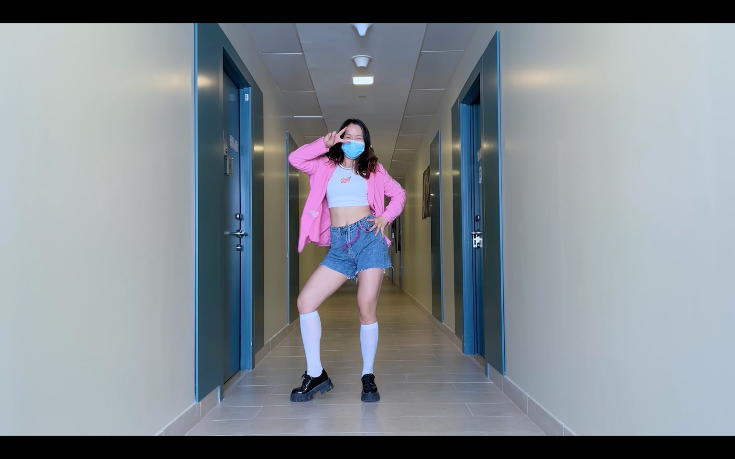

Pose 6 00:00:19:20 & 00:00:36:28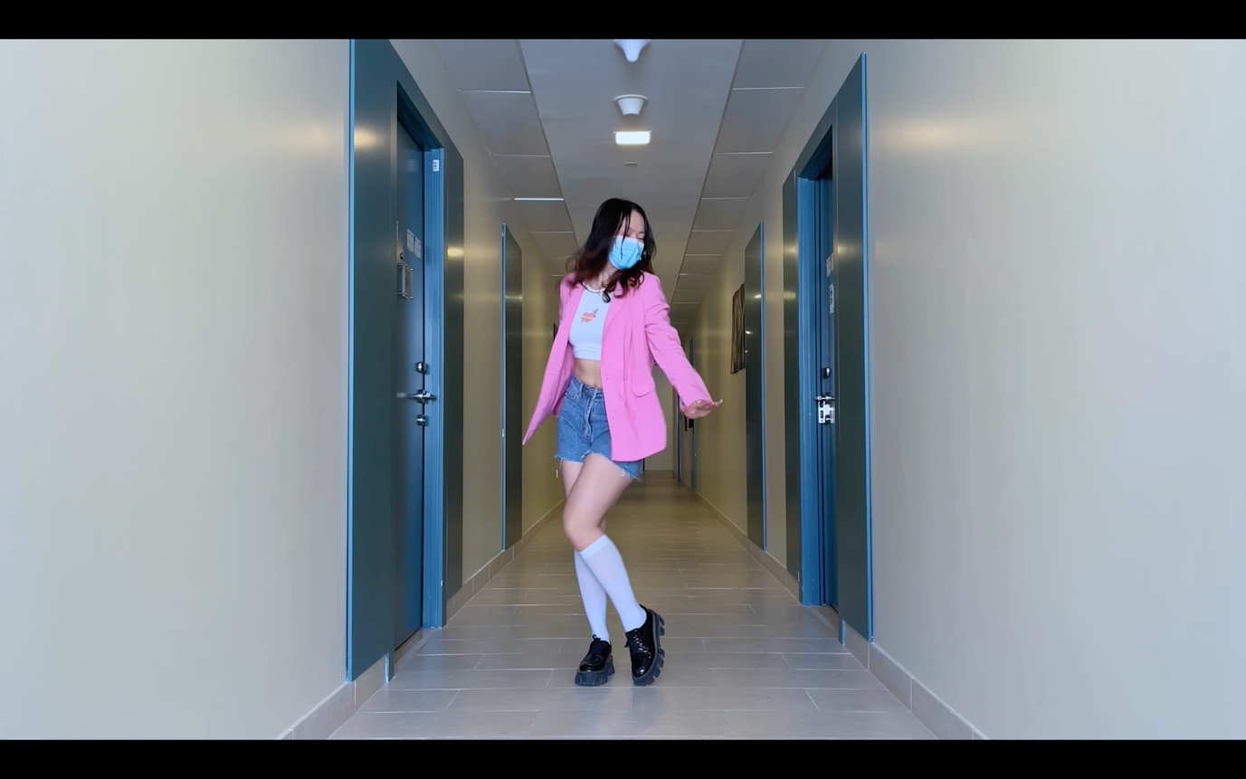

Pose 7 00:00:20:21 & 00:00:38:01

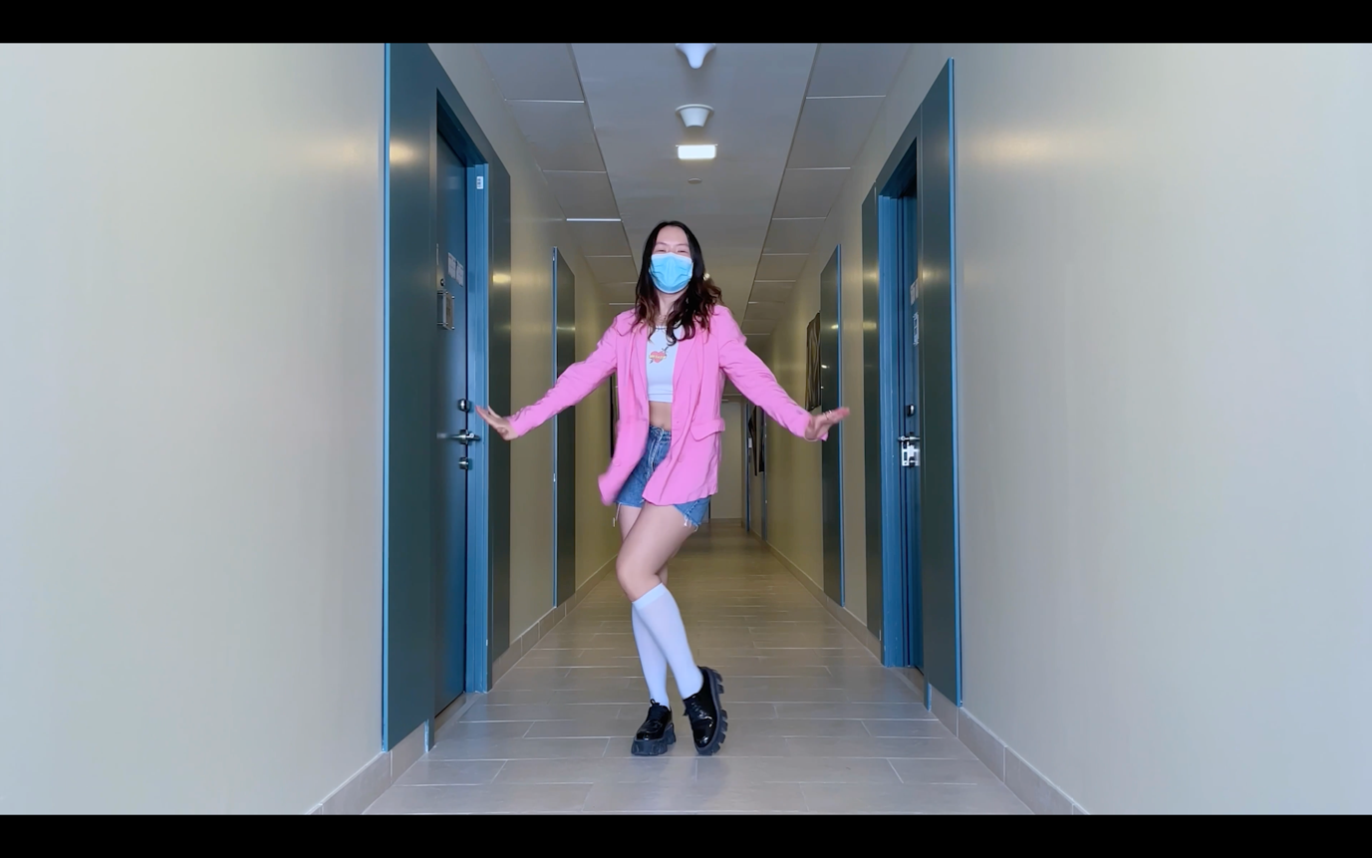

Pose 8 00:00:22:24. & 00:00:40:05

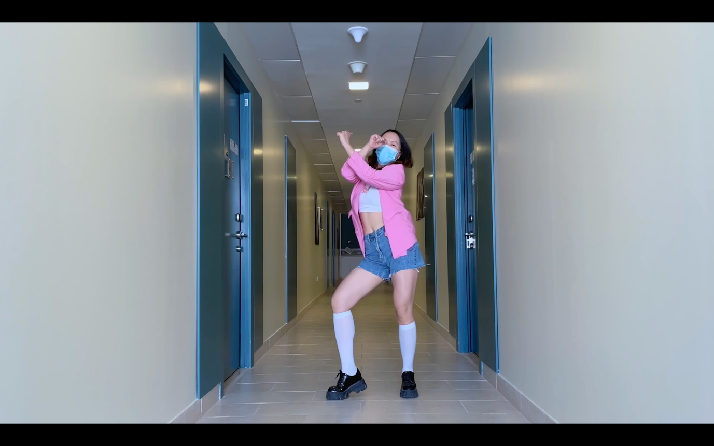

Pose 9. 00:00:25:14

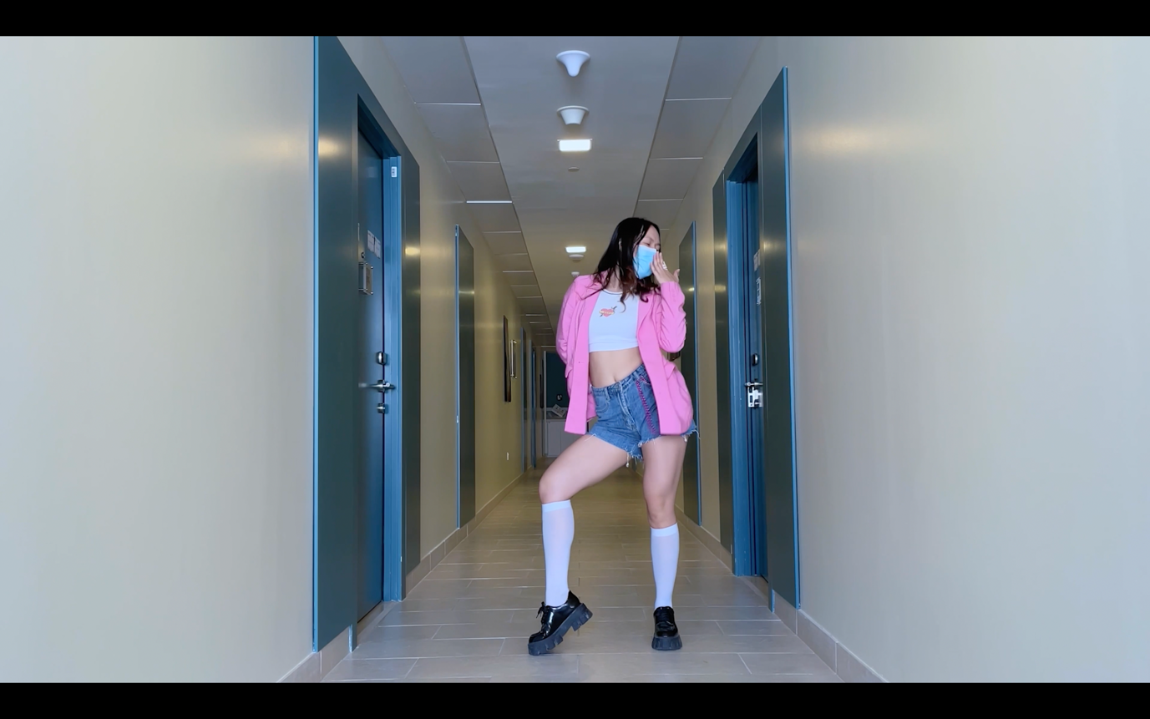

Pose10. 00:00:27:17 & 00:00:44:25

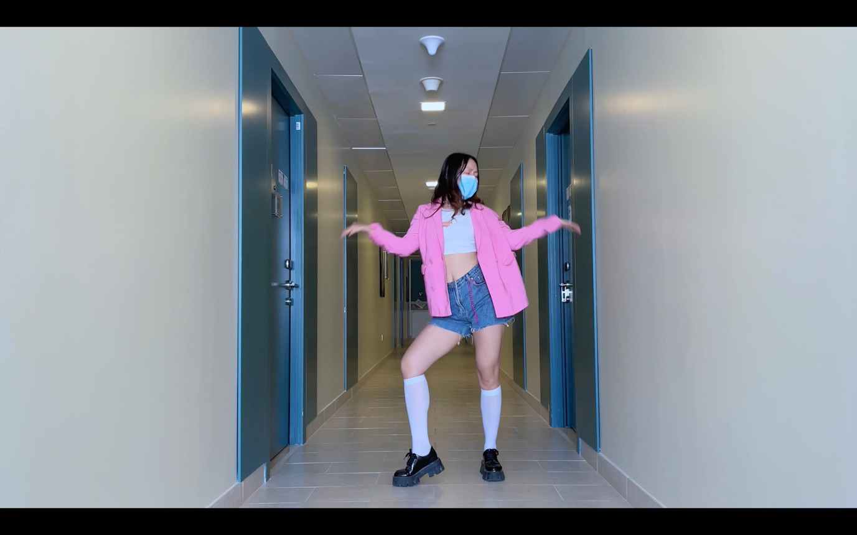

Pose11 00:00:29:10 & 00:00:46:18

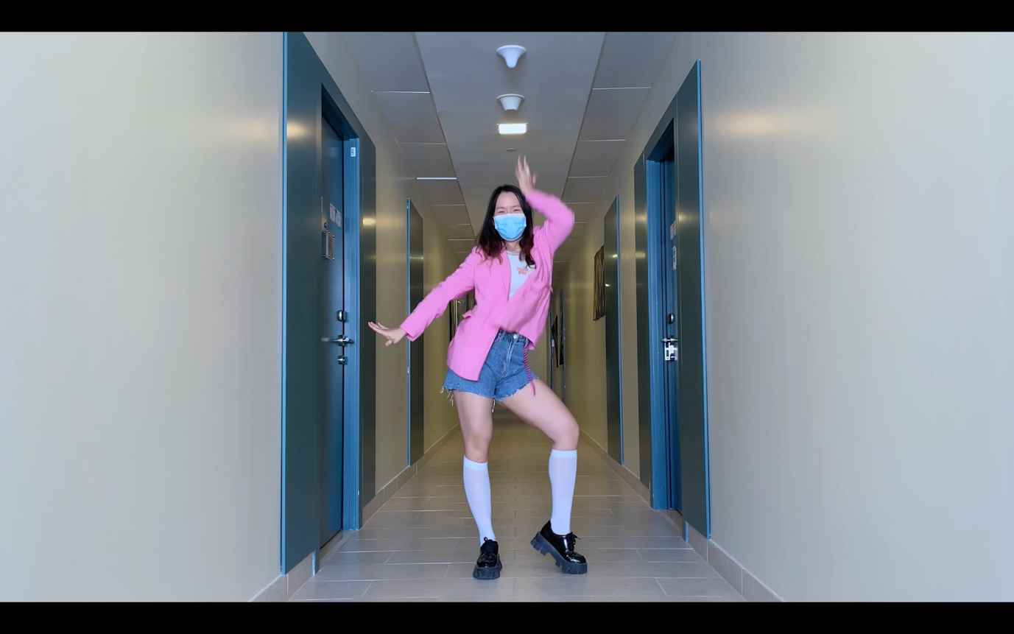

Pose 12. 00:00:33:21 & 00:00:50:26

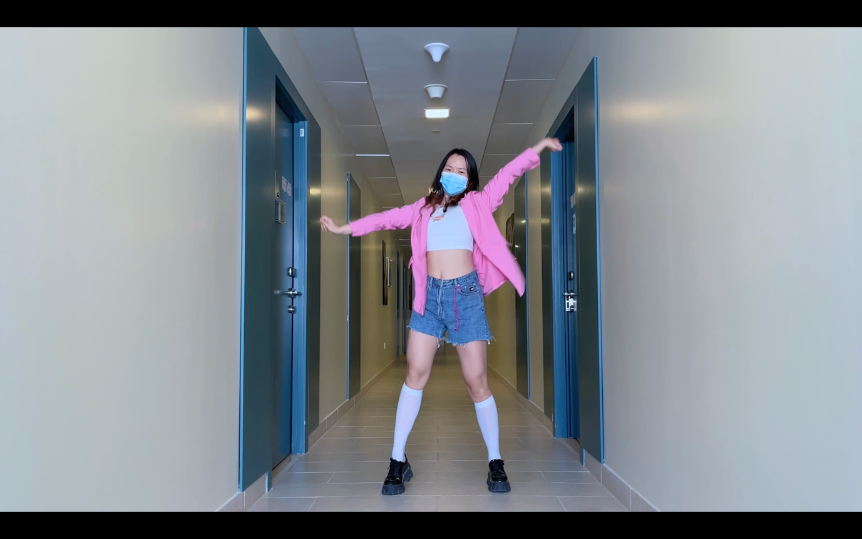

Pose 13. 00:00:34:06. & 00:00:51:16

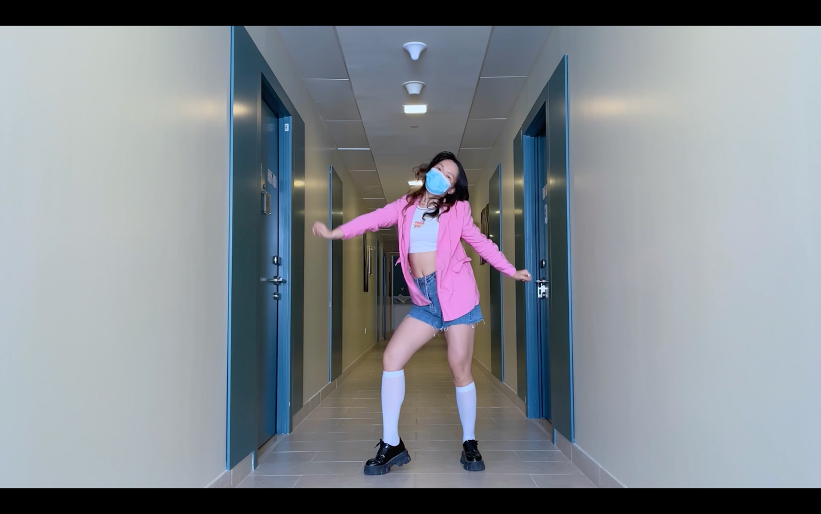

Pose 14. 00:00:35:11 & 00:00:52:24

